34.

<hr> : adds a border. Like seperates above and below content with a line.

<h1>Hello</h1>

    <hr>

    <p><b> I am Chicken</b>

<br> : breaks the line. Like when u write a poem.

<h2>The Road not taken</h2>

    <p>

        Two roads diverged in a yellow wood, <br>

        And sorry I could not travel both<br>

        And be one traveler, long I stood<br>

        And looked down one as far as I could<br>

        To where it bent in the undergrowth;<br>

    </p>

<h1>Hello</h1>

    <hr>

    <p><b> I am Chicken</b>

Caffeine: C8H10N4O2

<sup> : superscript

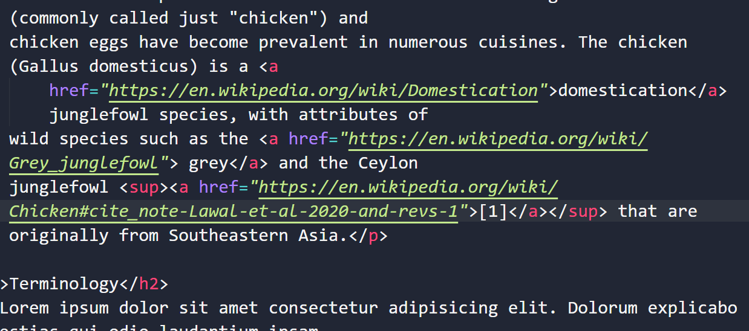

<sub> : subscript

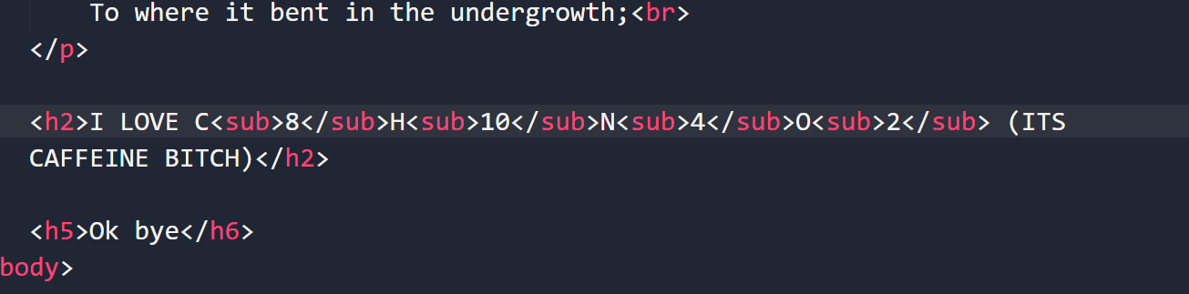

Entity Codes:

Starts with & and ends with ;

Used to denote special characters and symbols

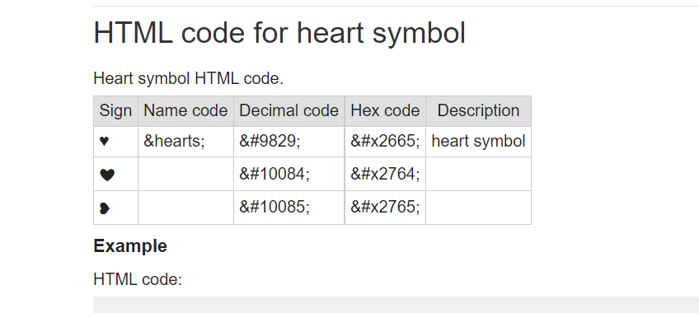

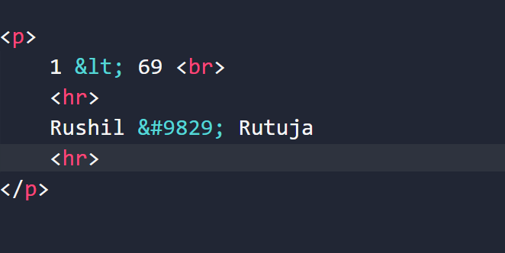

Reference: <https://dev.w3.org/html5/html-author/charref>

36

Semantic Markup:

Some elements that you use instead of old school elements so as to make your code more readable, more fast and more clean.

Gives a meaning to markup.

37

HTML Semantics:

<https://www.w3schools.com/html/html5_semantic_elements.asp>

nav:

supposed to represent any section of the page that contains navigation links (could be links to the same page different section or other page links).

Notice that NOT all links of a document should be inside a <nav> element. The <nav> element is intended only for major block of navigation links.

Like when there’s a group of links so u use nav

<Section>

Used to represent a particular section of the page. Doesn’t do anything more but atleast better than <div>.

Can use section instead of <nav>

Can be used to group certain parts of the page. Like the heading, info and footer.

<article>

<aside>

<header>

39. VS Code Emmet tool

Shortcuts to write code more efficiently and easily with less time.

For ex: ui>li 🡪 This is a command that will write the code as

<https://docs.emmet.io/>

43.

TABLES

<tr>

Used to specify a particular row

<th>

Used to specify the headings like shown in image below

<td>

This represents the data of the cells in the table.

<table>

        <tr>

            <th>Company</th>

            <th>Contact</th>

            <th>Country</th>

        </tr>

        <tr>

            <td>Alfreds Futterkiste</td>

            <td>Maria Anders</td>

            <td>Germany</td>

        </tr>

        <tr>

            <td>Centro comercial Moctezuma</td>

            <td>Francisco Chang</td>

            <td> Mexico</td>

        </tr>

        <tr>

            <td>Laughing Bacchus Winecellars</td>

            <td> Yoshi Tannamuri</td>

            <td> Canada</td>

        </tr>

    </table>

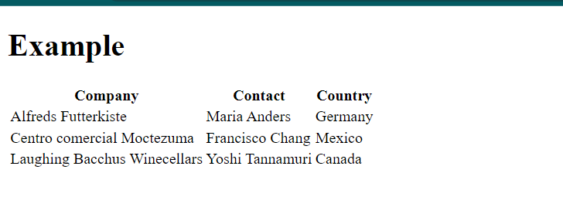

<thead>

Good practice to specify the heading part of the table so as to make the code more readable especially helps when dealing with complex tables.

<tbody>

Specifies the body

<tfoot>

Specifies the bottom of the table that is not included in the data of the table for ex average of the particular column.

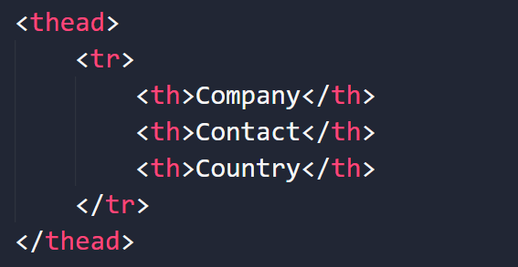

Colspan: Split the heading into multiple columns

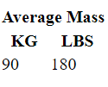

Rowspan: Split the heading into multiple rows

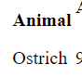

**FORMS**

Groups together inputs and then submits them together to some specified destination.

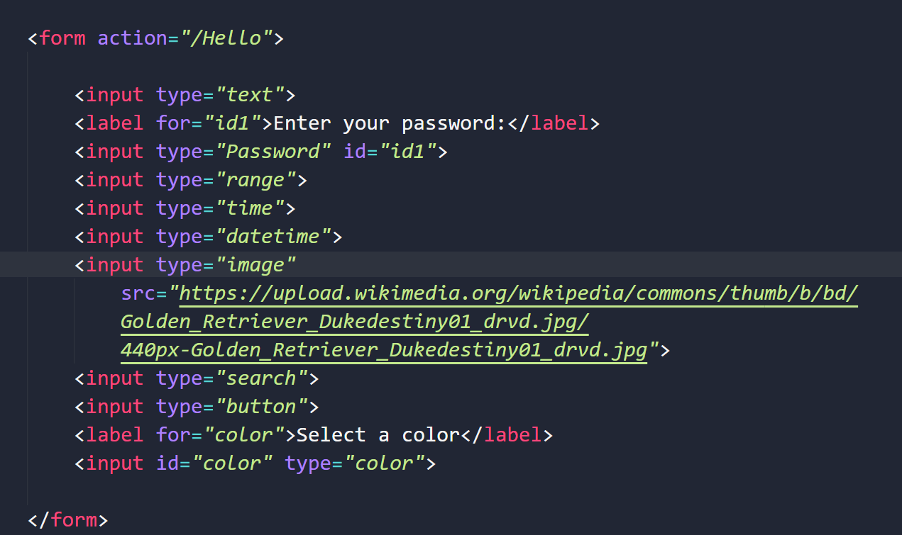

Label and input

**BUTTONS**

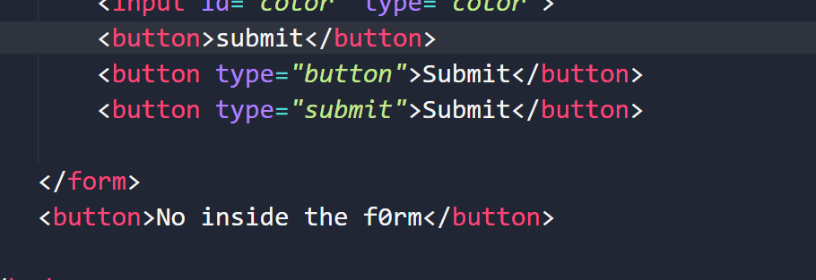

By default, buttons are meant to submit the form when its inside the form and when outside, it does nothing as of now cuz no javascript logic. So if u want it to be just a button but not submit it while it being in the form, u can specify it in the button tag itself like done in the image above.

<button type=”button”>This button will not submit</button>

<button type=”submit”>This button will submit</button>

**To know more:**

<https://developer.mozilla.org/en-US/docs/Web/HTML/Element/input/button>

All input types are covered in the code files. You can also visit MDN Docs for reference.

Some imp attributes:

Minlength: Used to have a minimum length of input

Maxlength: Max length of input

Min: A particular value should be greater than or equal to the min value. Like month. Must be >= 1

Max: Month. Must be <=12 so max=”12”

Placeholder: Text that appears before you write anything in the text box.

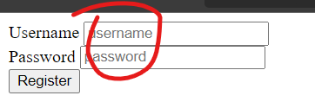

Required: If used, the form wont be submitted unless you put an entry in that particular field.